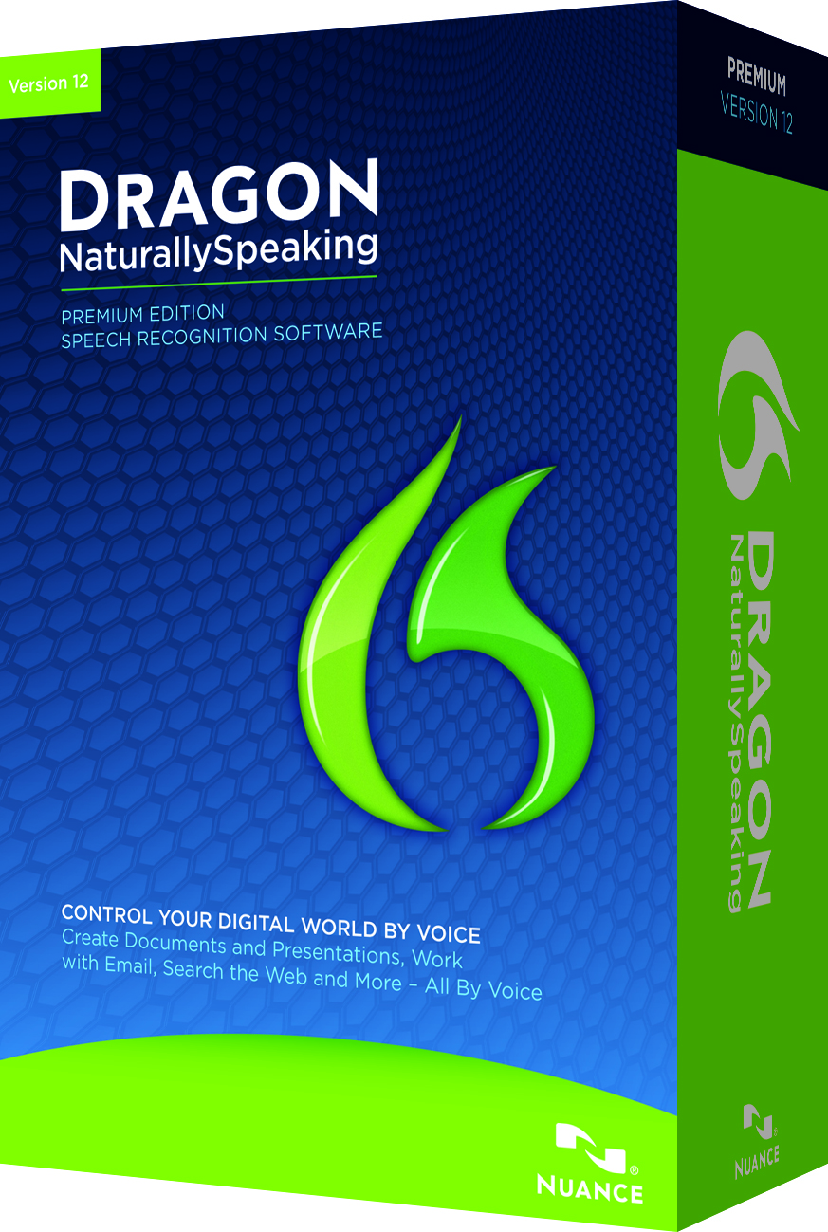
Dragon Reignites Global Career Success For Business Author
Dee Blick is a self-employed marketing professional, founder of The Marketing Gym and author of three best-selling business books. There is no doubt that Dee is successful, but what people don’t know is that she attributes her success to Nuance Communication’s award-winning Dragon NaturallySpeaking, the world’s best-selling speech recognition software. It turns talk into text and can make virtually any computer task easier and faster, from capturing ideas and creating documents, to email and searching the web, to using simple voice commands to control many of the popular programs you use every day at home or work.
Fifteen years ago, Dee started suffering from pain in her upper body when she was typing. Unfortunately she was battling with the debilitating pain of Repetitive Strain Injury (RSI) which was becoming increasingly more painful and difficult to manage. Using Dragon marked the start of a turning point for Dee in coping with her condition, while maintaining her successful career. This is because Dragon enables users to easily access all the communication, entertainment and productivity applications of a PC, simply by speaking, putting an end to using the keyboard and mouse and the pain this inflicts upon people with RSI.
Reflections on RSI
Dee explained: “I first started getting the painful symptoms of RSI fifteen years ago. It kept getting worse and worse and I am not ashamed to say I was spiralling into a depression. I had severe pain in my upper body and was really struggling to continue to work. This was completely devastating, especially as a writer; the thing that I was best at and made a living from was causing me so much pain. It was awful.”
Dee was thrown what proved to be an incredible lifeline when authorised Nuance reseller Hands-Free Computing introduced her to Dragon NaturallySpeaking. It explained how Dragon – which has accuracy rates of 99% and enables users to dictate at up to 160 words a minute - could change her life and reignite her career, simply by dictating words into her computer rather than typing them.
Access to Work for continued success
Enthused by Dragon’s promise, Dee contacted Access to Work, the Government scheme that provides people with the equipment and support they need to stay in work. Following a workplace assessment, it was decided that Dee qualified for Dragon NaturallySpeaking and she was subsequently trained how to use it to ensure that she could enjoy its full benefits – including the ability to use all popular Microsoft Office applications, search the internet and create and send emails, all by voice. With the latest version of Dragon – which is supplied with a comfortable to wear, high-quality headset - the enrolment process is very straightforward and most users are up and running and achieving high levels of accuracy within minutes.
Furthermore, as Dragon learns each user’s voice profile and style of dictating, it gets even more accurate each time it is used, further limiting the need to make corrections.
Today, everything Dee writes is dictated to Dragon, which means that her RSI no longer restricts her at work. Dee credits the software for keeping her in business and allowing her to continue marketing and writing. “Without the help of Dragon, I know that I could not have continued with my business, let alone become a bestselling author,” she says.
New levels of productivity and opportunity with Dragon
Dee believes there could be a benefit to all professionals – not just authors - in using speech recognition software; because we talk three times faster than we type, it boosts productivity dramatically. Therefore, Dragon enables even the busiest user to power through their workload, creating highly accurate documents very quickly. “I think there are so many benefits to Dragon even if you aren’t disabled. If you are an author it can completely change your writing style - I believe the reason why my books have been so successful is because the software enables me to have a friendly conversation with my reader.”
Fifteen years on from the first symptoms of RSI and nine years on from first using the software, life is very different for Dee. “I went from being absolutely desperate to being a bestselling author. I would never have been able to write any of my books without Dragon.”
Dee will always have RSI but knows that without the help of Dragon her condition would have worsened and brought her business to a halt and she would never have written three books. From hitting rock bottom, Dee is now flourishing in her career and it looks as if, thanks to Hands-Free Computing and Dragon, this will continue.
Profile
- Dee Blick
- Business writer and marketing professional
- Globally recognised, successful author
Challenge
- Extreme pain from RSI
- Business faltering as RSI made writing and typing difficult
Results
- Business now back on track thanks to Dragon
- New books - dictated using the power of Dragon - now published

www.nuance.co.uk

